Software Engineering Group Project

Word Template

|  |  |
| --- | --- |
| Author: | A. N. Other |
| Config Ref: | SE_N66_xxx_xx |
| Date: | 2010-10-11 |
| Version: | 1.2 |
| Status: | Draft |

Department of Computer Science

Aberystwyth University

Aberystwyth

Ceredigion

SY23 3DB

Copyright © Aberystwyth University 2008

CONTENTS

CONTENTS 2

1. Introduction 3

2. Purpose of this Document 3

2.2 Objectives 3

3. BODY OF DOCUMENT 3

REFERENCES 3

DOCUMENT HISTORY 3

# Introduction

## Purpose of this Document

The purpose of this document is to describe the project plan for the Monster Mash CS22120 Group Project 2012/13.

## Scope

This project plan aims to set general design goals, high-level software decisions and goals to work towards, given the client’s requirements. All project members are required to read this document to gain an understanding of the project parameters and goal solutions.

## Objectives

The objectives of this document are:

* to indicate the general overview upon which the development of the project is based upon. This should include the choice of platform that the project will be developed on, technologies under-pinning this and the project’s target users;
* to explain how users can interact with the system via a use-case diagram;
* to give a proposed GUI design of the completed project through interface sketches and drawings;
* to give a general time-line spanning the course of the project and proposed start/end dates for different aspects, via a Gantt chart;
* to analyse potential risks that may appear during the development of the project and propose solutions that may help mitigate such risks, by drawing up a risk table.

# BODY OF DOCUMENT

Front material is stored in document properties. These are not the correctly named properties but their use permits automation of running header update. Editing the front material will make changes throughout the document.

Titles, headings, body, bibliography entries, captions and table of content entries are defined as shown in Figure 1

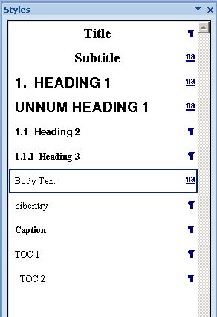

Figure 1: Recommended styles

REFERENCES

[1] Software Engineering Group Projects: General Documentation Standards. C. J. Price, N. W. Hardy. SE.QA.03. 1.5 Release

DOCUMENT HISTORY

| *Version* | *CCF No.* | *Date* | *Changes made to document* | *Changed by* |
| --- | --- | --- | --- | --- |
| 1.0 | N/A | 12/09/08 | N/A - original version | CJP |
| 1.1 | N/A | 2010-10-12 | Updated to Office 2007; key field automation increased; paragraph styles updated | NWH |
|  |  |  |  |  |
|  |  |  |  |  |
|  |  |  |  |  |
|  |  |  |  |  |
|  |  |  |  |  |
|  |  |  |  |  |
|  |  |  |  |  |
|  |  |  |  |  |
|  |  |  |  |  |